Nepal College of Information Technology
Assessment
Spring 2011
Program : BE IT/ELX Time : 3 hrs
Semester : Spring (II) FM : 100
Subject : Engineering Math-II PM : 45

- Candidates are requested to give their answer as far as practicable in their own words.
- The figure in the margin indicates the full marks
- Attempt ALL question

1. a) Find the shortest distance between the line 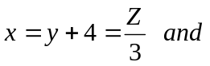
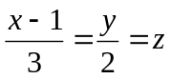
Find the equation of shortest distance. 8

b) Find the equation of perpendicular from the point (1,6,3) to the line 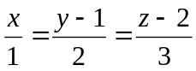. Find the foot of perpendicular and length of perpendicular. 7
2. a) Solve the differential equation 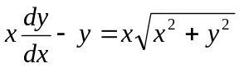 7
b) Solve y’’+8y’+16y=64 cosh4x 8
3. a) Solve the differential equation
y”+2y’+y = 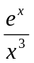 8
b) By power series method, solve y”+4y=0 7
4. a) Find the Laplace transform of (Any two) 4*2=8
i) 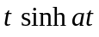
ii) 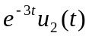
iii) 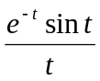
b) Solve the differential equation
y’’+4y’+3y=e^{-t}, y(0)=y’(0)=1 by using Laplace transform. 7
5. a) Evaluate 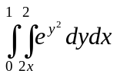 7
b) Evaluate
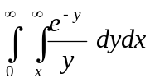 8
6. a) State and Prove Euler’s theorem on homogeneous function of two variable’s and prove that
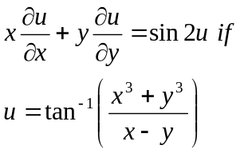 4+4
b) A rectangular box, open at the top, is to have volume 32c.c. Find the dimension of box requiring least material for its construction. 7
7. Attempt (Any five) of the following: 2*5=10
a) Find the equation of the plane through (4,5,1), (3,9,4) and (-4,4,4).

b) Solve: log (y’)=3x+4y

c) Show that Laplace transform is linear.

d) Find the Laplace transform of u_{a}(t)
e) If 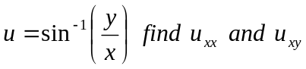
f) If 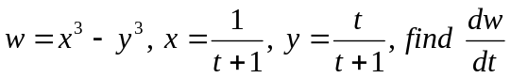 by using partial derivative.

